**Pakistani News Media Visualization**

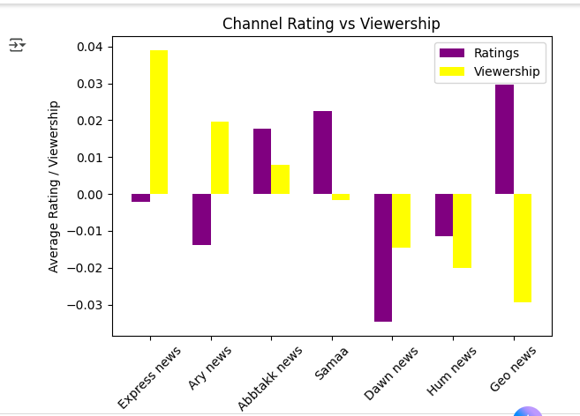

**ANALYSTICAL REPORT:**

This dataset shows how media content in Pakistan might be influenced by political interests, advertising money, and editorial decisions. After cleaning the data, we found that channels and journalists with pro-government alignment often receive higher advertising revenue and airtime. On the other hand, journalists marked as neutral or opposition sometimes appear to get less airtime and lower ratings visibility. When advertising spending increases on a channel, that channel’s sentiment toward the government becomes more positive, and sensitive topics like corruption and political scandals are reported less. This suggests a possible link between money and favorable media coverage.

In data analysis, we also saw that some journalists stand out because they appear more frequently with higher ratings and views. For example, journalists like *Kamran Shahid, Shahid Masood, and Rauf Klasra* were shown more often in trending or high-rating news, which means they have stronger media presence. Meanwhile, some journalists were reporting on many random topics outside their field (like political reporters covering sports or entertainment), which may show editorial pressure or data mislabeling. Topics like Sports and Entertainment were shown more, while corruption and political accountability were less highlighted, especially on pro-government media outlets.

These patterns do not fully prove manipulation, but they clearly show that money, politics, and media content are connected in this dataset. However, because some values were missing, wrongly entered, or inconsistent, we cannot be 100% sure. This report suggests that media data should be collected with proper rules, correct topic labels, and transparent bias scoring to make future investigations more trustworthy.